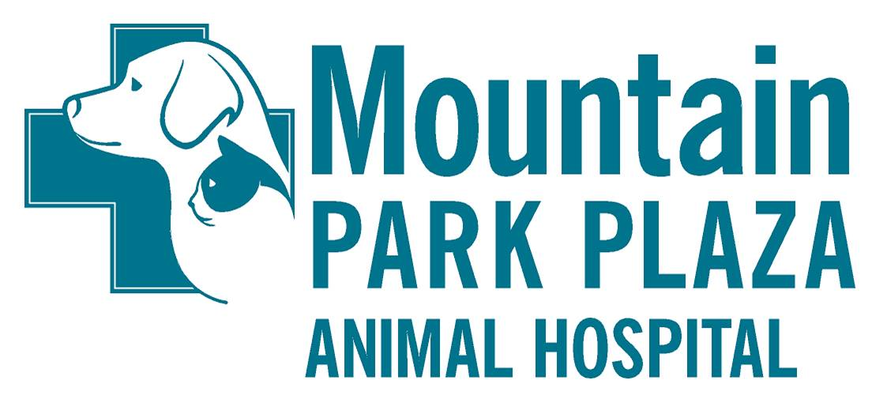

Owner Name__________________________________ Spouse Name___________________

Address_______________________________________________________________________

City_________________ ___ Zip__________ ______ County__________________

PRIMARY PHONE______________________SECONDARY PHONE__________________

E-mail _______________________________________________________________________

Driver’s License #___________________ State_______ (requested for payment purposes)

ALL FEES ARE DUE AT THE TIME SERVICES ARE RENDERED

PATIENT INFORMATION
PET #1 PET #2 PET#3

Pet’s Name _____________ ____________ ______________

Breed _____________ _____________ ______________

Date of Birth _____________ _____________ ______________

Color _____________ _____________ ______________

Sex (Male/Neutered)
(Female/Spayed) _____________ _____________ ______________

Vaccines last given
(approx. date/location) _______________________________________

For the protection of your pet’s and other patients health we require that pets staying in the facility (boarding, grooming, etc.) be current within 1 year for the following vaccines/lab tests:
DOGS: RABIES, DHLP-P, BORDETELLA, HEARTWORM EXAM, FECAL EXAM.
CATS: RABIES, FDVRCPn, FECAL EXAM.

If the vaccine information that you provide does not meet our requirements, the vaccines/lab tests will be updated accordingly. By frequenting MPPAH I give my permission for any media (photos/video) taken of my pet to be used on facebook or the hospital’s website.

Client Signature __________________________________ Date: _______________

